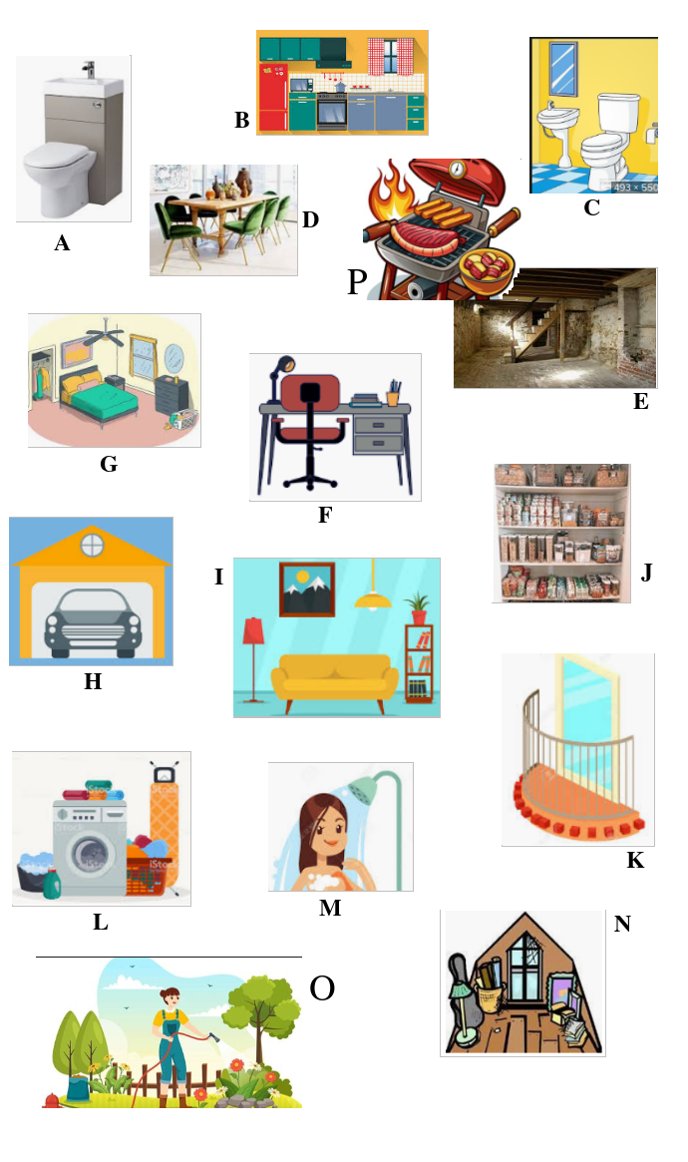
English Vocabulary : Places in a House/Apartment

Exercise: Link the images with the correct names.

attic
balcony
barbecue (BBQ)
basement
bathroom
bedroom
dining room
garage
garden
home office
kitchen
living room
laundry
pantry
shower
toilet

